Meet our Teachers

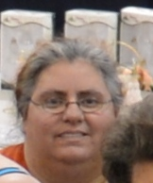
Davina Achen, WA
One of my first ever memories is my grandmother teaching me to crochet a chain so I would leave her alone so she could watch "All My Children" in peace. I also remember her surprise when I had chained thru the whole skein of yarn. In the 40+ years since that day, I have done everything I could to learn more and more.
As I grew up, my grandmothers thought me all the fiber arts, knit, crochet, embroidery and the like. In my rebellious teen years I experimented with clothing design, paper arts and poetry. In adulthood, I discovered the dark allure of power tools. I have spent the past decade mixing and mingling ideas and concepts together to produce the ideas and concepts that magically inhabit my brain until they reach fruition.
Over the years I have taught all ages, from Brownies to Eagle Scouts and beyond. I have published several tutorials on everything from Kumihimo to Lampwork to Resin Jewelry. I have won several awards over the years but the one I am most proud of is winning "Best of Show" in Tatting at the Spokane Interstate Fair this past September.

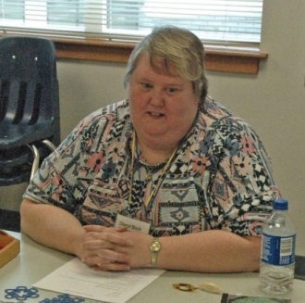
Cheryl Birch, OR
I learned to tat in 1980 with a shuttle, did very little until I found needle tatting from Barb Foster at around 1994. Picked up needle tatting and at some point about 1998 I found The Shuttlebirds Workshop, and was determined to needle tat my way through the first workshop, but got a renewed gumption at shuttle tatting while there. I started teaching needle tatting at Ben Franklin and another craft store. I finally mastered shuttle tatting and have not gone back to needle tatting since then. I have left off teaching at the craft stores and started teaching at two of the senior centers here in town because there was an amazingly long periods at a time when no one signed up. And now I have dropped down to only one Senior Center and have a couple of students who have faithfully returned term after term for about 6 years now. I have also taught at the workshop in the past.

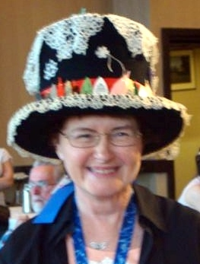
Venessa Godfrey, OR
In 1980 I took a class in tatting in Biloxi, MS. Being in the military, we moved quite a bit and I passed on the art of tatting wherever we went. There are now tatters in CA, MN, AL, OH, UT, ID and Or who learned the art of tatting through my teaching. In 1996 we moved to Albany, OR and I taught tatting through Linn-Benton Community College’s extended learning program. In 1998 we moved to Salem, OR. Here I have worked with the Willamete Heritage Center at the Mill teaching and setting up the 2nd Saturday demos at the Mill. We encourage folks who stop by to watch us to try tatting. I have also demonstrated at the State Fair and various county fairs and wherever invited. In June 2015 I will have the privilege of teaching the tatting class at the Pacific Northwest Lace conference.

Diana Howe, WA
I have 33 years of tatting and designing experience. My tatting has won first place ribbons and class winners for various entries in the Evergreen State Fair. I have also won the first place and grand champion ribbons for a tatted collar at the Puyallup State Fair. A tatted collar pattern designed by Mona Hahn and myself was published by House of White Birches. I also taught at the 1st Annual Tatting Summit of Puget Sound in Oct. 2012.

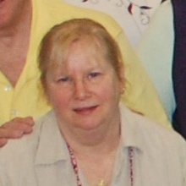
Mary McCarthy, WA
I learned to tat in 1979 at the Renton Recreation Dept. from Blanche Brown. Not being able to find many patterns, I started making my own and submitting them to magazines like McCall’s Needlwork & Crafts, The Workbasket and Better Homes and Gardens Special Interest. I also edited Alice Heim’s DMC Bridal Tatting Book. I later published KNOTS! For 10 years.

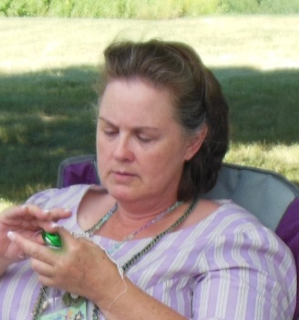
Kathleen Minniti, WA
I have been tatting for about 40 years, and at last year’s workshop, I was inspired to “up my game”. I began working to improve my own technical skills and start designing original work. I have taught basic introductory tatting for years, but have not had many opportunities to work with more experienced tatters until finding the Shuttlebirds in 2014. In May 2014, I shared one of my patterns with the online tatting class.
I am a member of the Shuttlebirds Tatting Guild and IOLI. Samples of my work can be found on the LaceIOLI and Craftree/Intatters websites. I am also the Minister of Arts & Sciences for the local branch of the Society for Creative Anachronism. My entries in the 2014 Spokane County Interstate Fair won all blue ribbons plus the Best of Show for the tatting division and Best Tatted Entry.

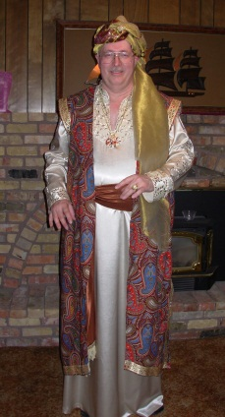
Dale Pomeroy, UT
Tatting is a branch of lace made by a lark’s spur/lark’s head knot on a running line using the hands and a shuttle, needle or hook. Through an extensive self-study program, I have been actively involved with this form of lace-making since I was twelve. I have been teaching tatting since 1981.

Natalie Rogers, WA
I was introduced to tatting in August 2012 by Donna Barnes. I have enjoyed crafts my whole life and was quick to pick up on the basics of tatting. I started teaching friends and family how to tat within a few months of picking up my first shuttle, because the easiest way for me to know I’ve learned a new skill is to teach it.
My co-blogger, Davina, and I run the Shuttlebirds blog. We have hosted a weekly free pattern challenge since May of 2013. Completing a minimum of one tatted piece a week has provided me with a lot of tatting practice. I love the challenge of learning new techniques.
My first designs happened by accident as variations on patterns I was completing. Since those first few happy accidents, I have enjoyed purposefully designing many more tatted pieces.
I have actively participated in several of the Shuttlebirds Tatting Guild’s demonstrations. It is a delight introducing others to the art of tatting. I look forward to sharing the techniques that I have learned and a few of the designs that I have made with you.

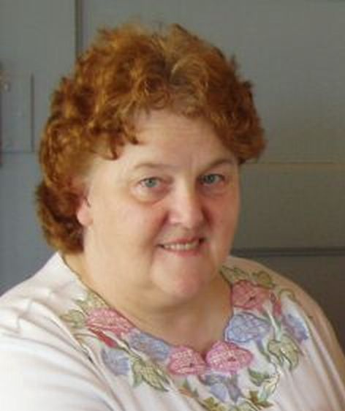
Georgia Seitz, IL
It is hard to believe that I have been tatting for 35 years. It was in 99 that I actually learned to tat and in 1985 began teaching. In 1995 I attended my first IOLI convention. Since then I have taught at convention many times and several local workshops with groups across the country. I have written a series of tatting books, edited two tatting compilations and filmed my first tatting video. Additional books are in the works. I also continue to teach the online tatting class.

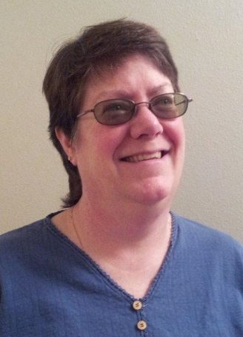
Lauren Snyder, WA
I learned to tat at an EAA Fly-In 20 years ago. Tatting has been an all- consuming passion ever since and I have been teaching for over 15 years. I like to keep things simple in tatting, even going so far as to use thread ends as a design element. My work has won many fair ribbons including Creative Awards and best of Show. My piece titled “En Plein Air”, a watercolor, quilted and tatting embellished mini quilt was published in the August/September 2014 issue of quilting Arts Magazine.

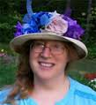
Karey Solomon, NY
I have been tatting for more than 40 years, and designing for a quarter of a century. For the past 24 years, I have been the designer/editor/publisher of the quarterly journal Tatting Times and am the author of 27 pattern collections. In 2012 I also became the tatting editor for the Bulletin for the International Organization for Lace, Inc. (IOLI).
My shuttles and patterns pack well and I’m always happy to travel with them. I’ve taught across the USA, as well as in Canada, England and Sweden, in privately organized classes, lace and tatting events, and at IOLI conferences. I tat a lot – and tat most days. I’m a vendor of tatting supplies and I also really enjoy hand-dyeing threads. I have taught at Shuttlebirds several times and loved being at each one of them.

Jessica Spaulding, WA
Jessica remembers being fascinated as a child by her grandmother’s tatting. She finally decided to take the plunge and learn while in college and has been obsessed with tatting ever since. She lives in Seattle, Washington and blogs about tatting at Snapdragonlace.com. Her hand-dyed threads and tatting patterns are available for sale on Etsy and Craftsy. This will be her 6th year teaching at Shuttlebirds.

